SOFTWARE REQUIREMENTS SPECIFICATION (SRS)   
FOR   
[Employee tracking system]

Prepared for:

NMInfotech Software and Security Solution

C-133,2nd Floor, Phase-8,

Ind.Area, Mohali-160071

www.nminfotech.com

Prepared by:

[NMInfotech]

**Approved: Accepted:**

**[Project Sponsor]**

**____________________________ _____________________________**

**[Designator] date [Software Project Manager] date**

**Accepted:**

**_____________________________**

**[Branch or Division] date**

RECORD OF CHANGES

|  |  |  |
| --- | --- | --- |
| **Version Number** | **Date** | **Description** |
|  |  |  |
|  |  |  |
|  |  |  |
|  |  |  |

ABSTRACT

Employee tracking system is a project that can be used by all the industries that are using internet to limit its use and consequently reduce the internet threads and cost. It makes easy for them to monitor its client’s currently using internet and also can manage them too.

**Table of Contents**

* **Table Of Contents**
* **Acknowledgement**
* **1.0 Introduction**
  + - **1.1 The WOLFMAN Employee Tracking System**
    - **1.2 Purpose**
    - **1.3 Goal**
    - **1.4 Employee Tracking System Project**
    - **1.5 Project Scope**
    - **1.6 Current System**
    - **1.7 Limitations of the Current System**
    - **1.8 Need Of The Application**
    - **1.9 Definitions, Acronyms and Abbreviations**
* **2.0 System Requirements**
* **2.1 Information Gathering**
* **2.2 System Feasibility**
* **2.2.1 Economic Feasibility**
* **2.2.2 Technical Feasibility**
* **2.2.3 Behavioral Feasibility**
* **3.0Requirement Analysis**
* **3.1 Input Requirements of the System**
* **3.2 Output Requirements of the System**
* **3.3 Special User Requirements**
* **3.4 Technologies Used**
* **3.5 Software Requirements**
* **3.6 Hardware Requirements**
* **4.0 Modules**
* **5.0 Design**
* **5.1 Design Goals**
* 5.2 Outer view of interface
* **6.0 Conclusions**
* **6.1 Limitations**
  + **6.2 Business Functions Provided In Proposed System**

ACKNOWLEDGEMENT

I would like to thank NMInfotech and my training Co-Coordinators Mr.Anirudh and Ms.Navpreet with who content guidance and help throughout the project. I would like to thank LPU with whom assurance I would have been able to continue my 6 months internship in this respective company.

Finally, I would like to thank my family and my friends for all support and encouragement.

INTRODUCTION

**1.1 The Wolf man Employee Tracking System Project**

It’s a project that can be used by all the industries that are using internet to limit its use and consequently reduce the internet threads and cost. It makes easy for them to monitor its client’s currently using internet and also can manage them too.

**1.2 Purpose:**

This is the software requirements specification of Wolfman Employee tracking system. It’s an enterprise application that will provide a web interface for all internet users to access internet daily. Moreover on server side there will another interface too for administrator to manage the users.

**1.3 Goal:**

The goal of this application is:

• To develop an easy to use Enterprise based interface where Admin can restrict Employees for internet resources, deeply monitor the employees and can manage them too.

• Online Remote Desktop to not only view but also access the desktop items.

• Use of Caching of web pages, efficient and advance algorithms for fast response to employee web request.

• Administrator can view each activity of employee and remotely take actions on them.

* Implement Private communication system by LAN CHAT

• Better Firewall to protect network from unwanted threads and vernubilities.

**1.4 Employees Tracking System Project:**

It will be an (J2EE) enterprise application that will provide a web interface for all internet users and desktop interface for administrator to monitor and manage the users. There is a list of functionalities that an administrator would be able to perform:

* **Internet Controlling**

Limit network Bandwidth.

Limit access Usage Time.

Limit Data Downloading.

Block Social Networking Sites.

Block Adult Sites.

* **LAN Chat**

Using wolf man a user can interact with other online users on the intranet.

Administrator can also broadcast the message to all other users online. Using wolf man

Employees can send, receive and can also share files.

* **File Sharing**

The users can share various kinds of files online on the intranet.

* **Desktop Online**

Admin can see the online desktop working of various online users.

* **Firewall**

It provides complete Security on various levels.

* **Reports**

This Software makes daily, weekly, monthly reports of Internet usage.

* **Software Controlling**

It controls the various software applications that can be executed on the user computer. Like we can restrict various software eg Torrent, Skype etc.

* **Manage Server**

It provides options to control Server.

* **Caching**

To increase speed and efficiency it provides Web pages Caching.

**1.5 Project Scope:**

* Manage employees Accounts.
* Use SSL (secure socket layer) for security.
* Have an availability of 99.999%.
* Manage online employees.
* Made solution to block chat software’s and downloader’s.
* Confirm security.

**1.6 Current System:**

As internet is become a need to every organization and as its demand is increasing people are misusing this service in their personal use instead of using it in organization benefit. There are some software to overcome this problem but either they are too costly or not reliable moreover many of them have limited functionality and hence for a complete network solution organization need to refer more than two or three software’s.

**1.7 Limitations of the Current System**

* Confusing Interface
* Limited functionality
* Unreliable on proxy software’s
* Unable to deeply monitor users

**1.8 Need Of The Application:**

There are many such software’s to track a user on internet but their confusing interface and inefficient reliability made administrator frustrate and less powerful moreover leaking of data and other security issues are also there. Users generally use third party chat messengers which increase cost and also create security issues.

**Problem:**

• The basic problems with the existing systems are the non-interactive environment they provide to the users.

• The use of traditional user interfaces which make continuous post backs to the server; each post back makes a call to the server, gets the response and then refreshes the entire web form to display the result. This scenario adds an extra trade off causing a delay in displaying the results.

• poor algorithms make system slow.

• Use of traditional and non user friendly interfaces that are hard to use

**Solution:**

• Fast response for client request due to advance and efficient algorithms and caching of web pages.

• Light weighted and multipurpose chat application helps in better communication and data sharing. .

• Provide Interactive interface through which a user can interact with different areas of application easily.

• Provide Drag and Drop feature thereby allowing the Administrator to add or remove client members from the authentic users database.

**1.8 Acronyms and Abbreviation:**

System Requirement Analysis

**2.1 Information Gathering**

The different users of the system are:

1. **Administrator:** Administrator will have all the privileges and configure this product with the required information like information of currently logged on users and currently active websites, reports, client desktop acess, bandwidth management, user management and all the left tasks in this system are managed by administrator.
2. **Client Users:** Any user who accesses this application using its web interface is termed as public user. A public user can create his/her account in this system. A public user can view all the grocery items; there prices and another related information of the system.

**Login:** The system users required to login through a login screen. After authentication and login he would be able to access internet but only within a confined boundary that administrator has set.

**LAN Chat:** The user will be able to chat with all other online users. They can also share files with each other. In this we provided the feature of NOTICE BOARD, in which the users will be updated with the new information regarding the Organization .

**2.2 System Feasibility**

The system feasibility can be divided into the following sections:

**2.2.1 Economic Feasibility**

The project is economically feasible as the only cost involved is having a computer with the minimum requirements mentioned earlier. For the users to access the application, the only cost involved will be in getting access to the Internet.

**2.2.2 Technical Feasibility**

To deploy the application, the only technical aspects needed are mentioned below:

* Operating Environment: Win 2000/XP/Linux/
* Platform :Net Beans Framework
* Database SQL Server 2005
* For Users: Internet Browser and Internet Connection

**2.2.3 Behavioral Feasibility**

The application requires no special technical guidance and all the views available in the application are self explanatory. The users are well guided with warning and failure messages for all the actions taken.

**3.0 Requirement Specifications**

**3.1 Input Requirements of the System**

* Login
* User Registration
* Documentation Information
* User identification Information

**3.2 Output Requirements of the System**

* User Maintenance
* Communication
* Reports

**3.3 Special User Requirements**

Remote access on client desktop.

**3.4 Technologies Used**

1. **JAVA :**

JAVA is Platform Independent, Secure, Object Oriented, Scalable and Robust Programming Language.

It consists of two parts

* JVM stands for Java Virtual Machine, which is run time environment to execute the java programs.
* Java API (Application Programming Interface) that consists of inbuilt classes used in java programs.

1. **JDBC :**

JDBC (Java Database Connectivity) is an API, which is used for the communication of java programs with different databases.

1. **Java Mail API :**

The Java Mail API provides a platform-independent and protocol-independent framework to build mail and messaging applications.

1. **Servlets :**

Servlets are basically a part of Java Platform, Enterprise Edition (Java EE) and is a technology that is used for extending the functionality of the servers that host application access via request-response programming model.

1. **JSP :**

JSP (Java Server Pages) a technology of Java Platform, Enterprise Edition (Java EE) is used for server-side programming and with the help of JSP we can segregate the work of a web designer and a developer.

1. **EJB (This technology now not used but in future may be) :**

Enterprise JavaBeans (EJB) technology is the server-side component architecture for Java Platform, Enterprise Edition (Java EE). EJB technology enables rapid and simplified development of distributed, transactional, secure and portable applications based on Java technology.

1. **Web Services :**

Web services are Web based applications that use open, XML-based standards and transport protocols to exchange data with clients. Web services are developed using Java Technology APIs and tools provided by an integrated Web Services Stack which is available with Glassfish.

1. **Jasper Reports :**

Jasper Reports is an open source reporting engine. Using Jasper Reports can generated in any type of application i.e. console application, desktop application, web application, enterprise application.

1. **Scripting Language**

* HTML & CSS
* JavaScript
* XML,XHTML
* AJAX
* UML

1. **My SQL Server**

MySQL Sever is used as database, used to store data. It is RDBMS.

3.5 Software Requirements

* JDK 1.6
  + Net Beans 6.9
* J2ME
  + Sun Java Wireless Toolkit 2.5.2
* Database
  + My SQL Database Server
* Reports
  + Jasper Reports 3.1.2
* Web Server
  + Tomcat 6.0.18
* Application Server
  + Glassfish v2.1
* Testing Tool
  + JUnit 4.5
* Deployment Tool
  + Ant 1.7
* Operating System
  + Windows Vista / XP sp3/Windows 7

3.6 Hardware Requirements

Intel P4 processor with minimum 2.0 GHz Speed

RAM: Minimum 512MB

Hard Disk: Minimum 20GB

Display 16 bit Color

**4.0 Modules**

**Admin Module:**

This module is the central module of this application. This module provide user interface for the admin users to get all the information about the system and also for configuring the system with any required information. These users have all the rights for insertion, updation, deletion and etc.

**Reports:**

In this module all the reports are generated in pdf format. These reports are viewed by

admin, authenticated users, and stock maintainer.

**Firewall:**

Build solution to block chat software’s, downloader’s and others proxy servers.

**Remote Desktop:**

Allow administrator to view and access clients desktop.

**Bandwidth:**

Manage the internet bandwidth for the network also limit the uploading and downloading speed.

**Maintance:**

Maintain the users and server for a proper functionality.

**User login Module:**

This module will provide login to the users and their information according to their rights will send to the server. There will be an integrated user interface which will allow the users to chat with other clients and also share data.

**5.0 Design**

***5.1 Design Goals***

* + The design of the enteprise application involves the design of the desktop application interface for easily manage the clients, continuously track employees.
  + Design of an interactive application that enables the user to filter the products
  + Based on different parameters.
  + Design of an application that has features like drag and drop etc.
  + Design of application that decreases data transfers between the client and the server.

**5.2 Outer view of interface**

**Manage users**

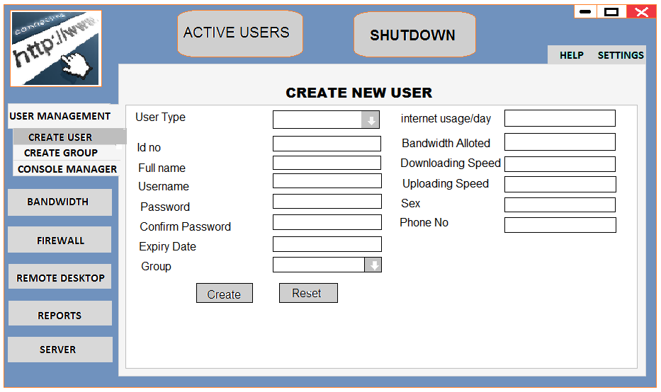

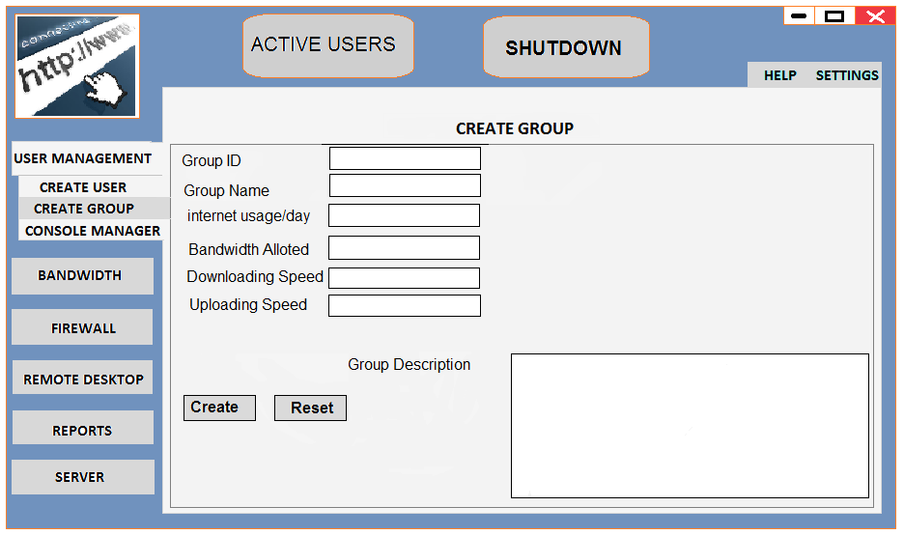

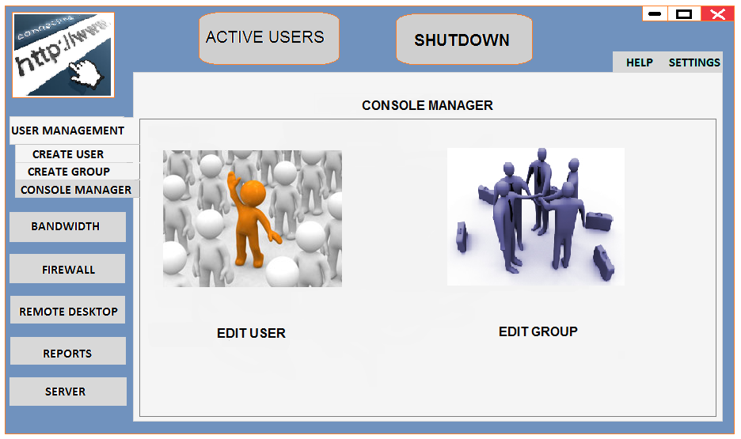

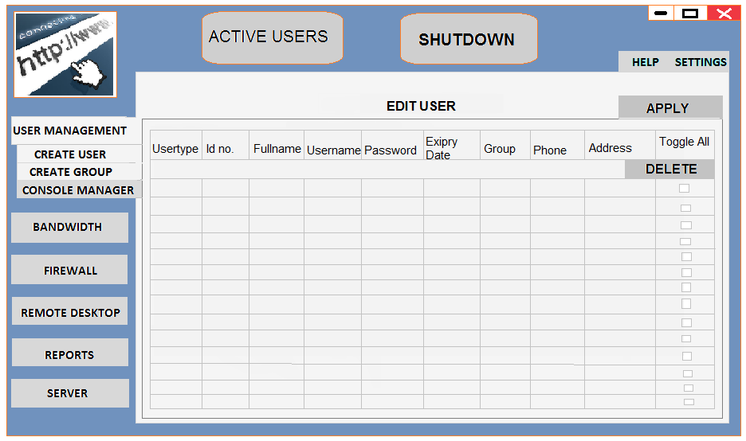

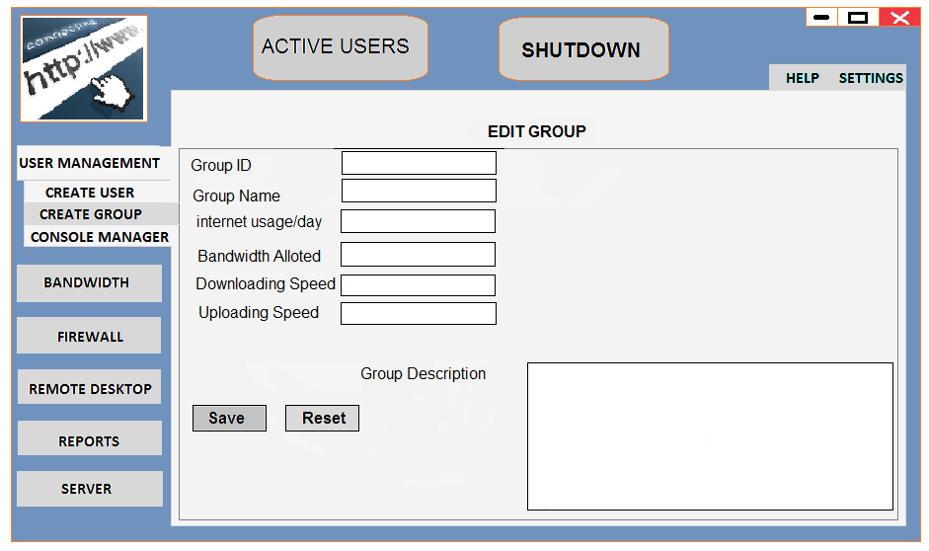

**DESKTOP ONLINE**

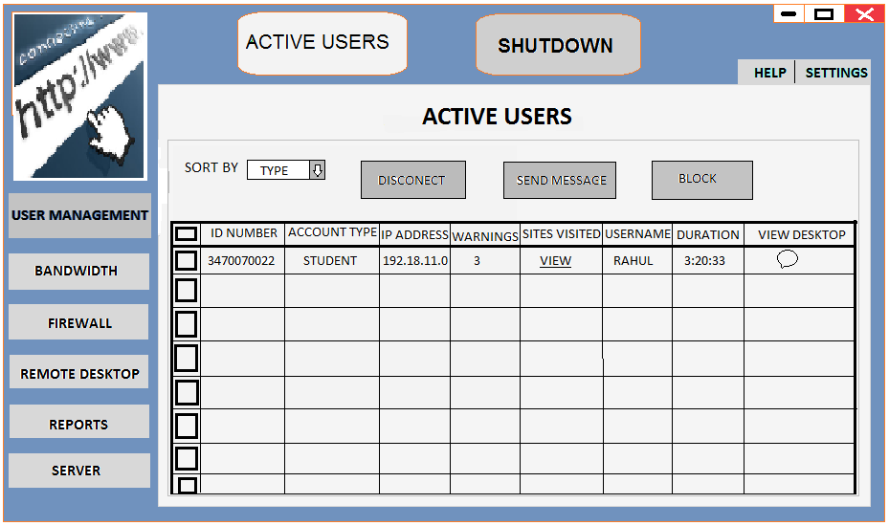

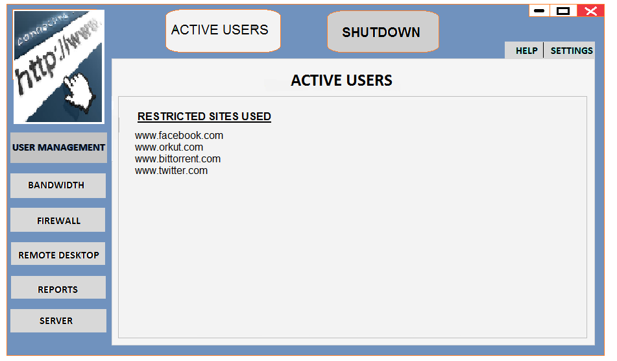

**FIREWALL**

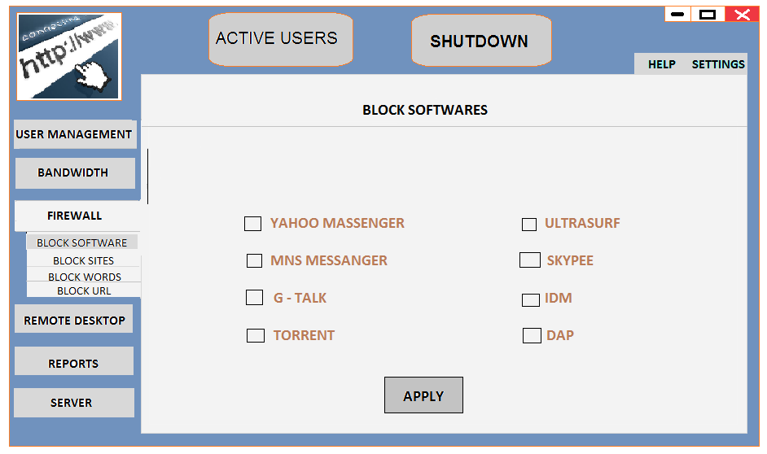

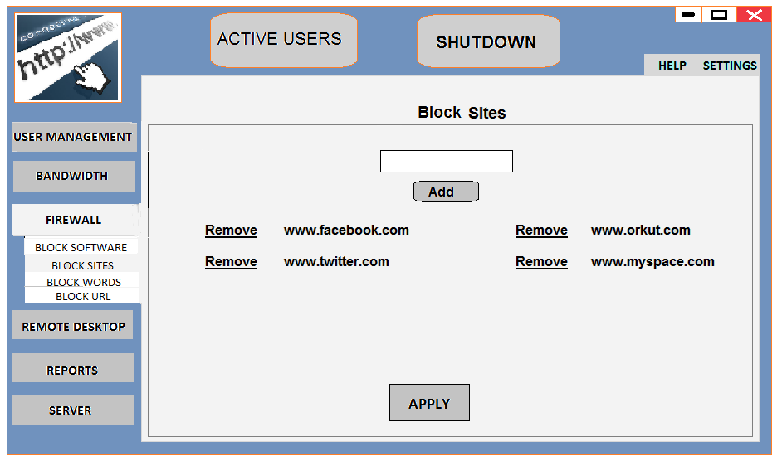

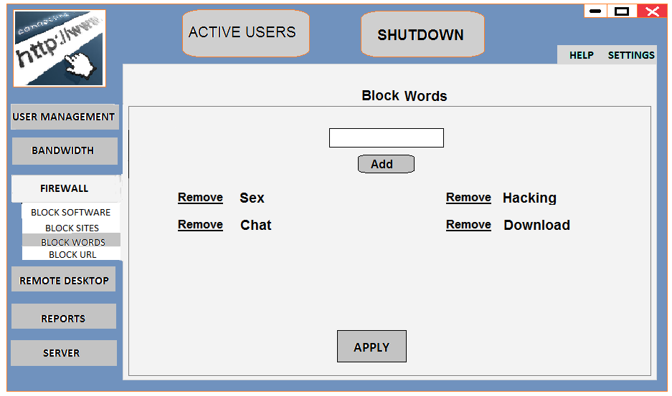

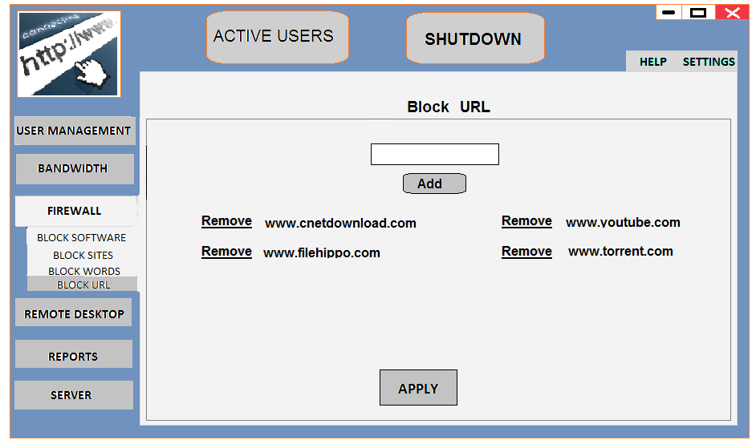

**MANAGE SERVER**

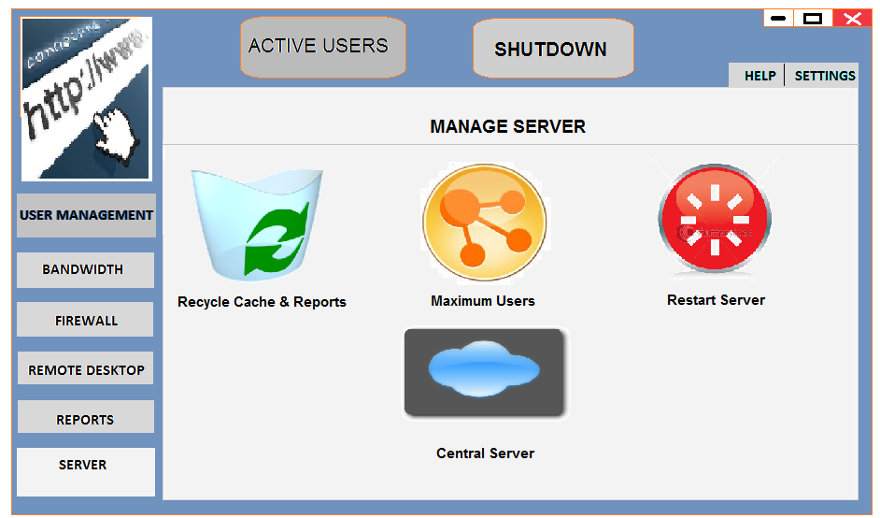

**6.0 Conclusions**

At last the main features that we provide are:

Bandwidth Management

Caching

User Access Control

Internet Usage Management

Firewall

Web Filtering

Virtual Data Storage

Management Reporting

Web-mail and Mail Server

Wolman is a tool that allows administrators to control traffic and make decisions about internet traffic thus shaping traffic flow to sets of user-defined behaviors. To increase efficiency and speed Wolman provides web site caching. This allows sites, pages or URLs to be stored locally in the server thereby reducing considerable load on available Internet Bandwidth.wolfman is capable of controlling Internet access, both on User and IP address basis, providing you an additional layer ofsecurity.Flexible time bound restriction can be applied for the Internet usage in accordance with the predefined user policy. Wolman acts as a powerful State full firewall, which is a complete security and control package. The filtering system filters sites deemed illegal, offensive, nonproductive, or contrary to education or work related activities, with a very high accuracy. Secure Data Storage vaults and data storage space for every user on server. Wolman reporting tools include graphical and statistical reports of individual users, time logs of employees on Internet, thus make the users accountable to their work.wolfman offers an optional facility wherein this acts as a robust Mail Server and offers web based access to mail

Accounts. To protect network against POP, SMTP based viruses, wolfman can be integrated with an anti-virus software to provide Gateway level security.

**6.1 Limitations**

There is a huge programming behind the blocking of particular software and to block any software we need to build different code hence its need lifelong support.

**6 .2 Business Functions Provided In Proposed System**

Increased User Productivity

Better Utilization of Expensive Bandwidth

Reduced Legal Liability

Higher Return on Investment

Policy Enforcement

Usage Accountability

Easy Monitoring

Automated Reports

Clean and Safer Environment

Wolman lets your employees leverage the power of Internet without allowing any distractions by banning access to unwanted sites/chat facility. Thus enhancing employee productivity. The two way restriction on Bandwidth available to every user helps you to manage this expensive resource efficiently. In order to limit the risk of legal liability, Wolman blocks the downloads of user defined type softwares.wolfman promises for you (for once, in technology) payback in weeks, if not in days. Wolfman helps you to enforce Internet usage policy which can be enforced on the basis of the user level in the hierarchy of your organization. With the help of various types of reporting tools in your hand, it will bind the user to make him accountable for the work he was Assigned. This enables you to keep track of the traffic incoming/outgoing at any point of time from your network with a few mouse clicks. The built-in automated process starts logging reports as and when a user login and thus provides you with different kinds of statistical and graphical representations. Once the Organization Internet usage policy is enforced, it will help you to make organizational environment more clean, safe and pure thus providing Internet experience of the best level